# Supplementary Material

## Tables and Figures

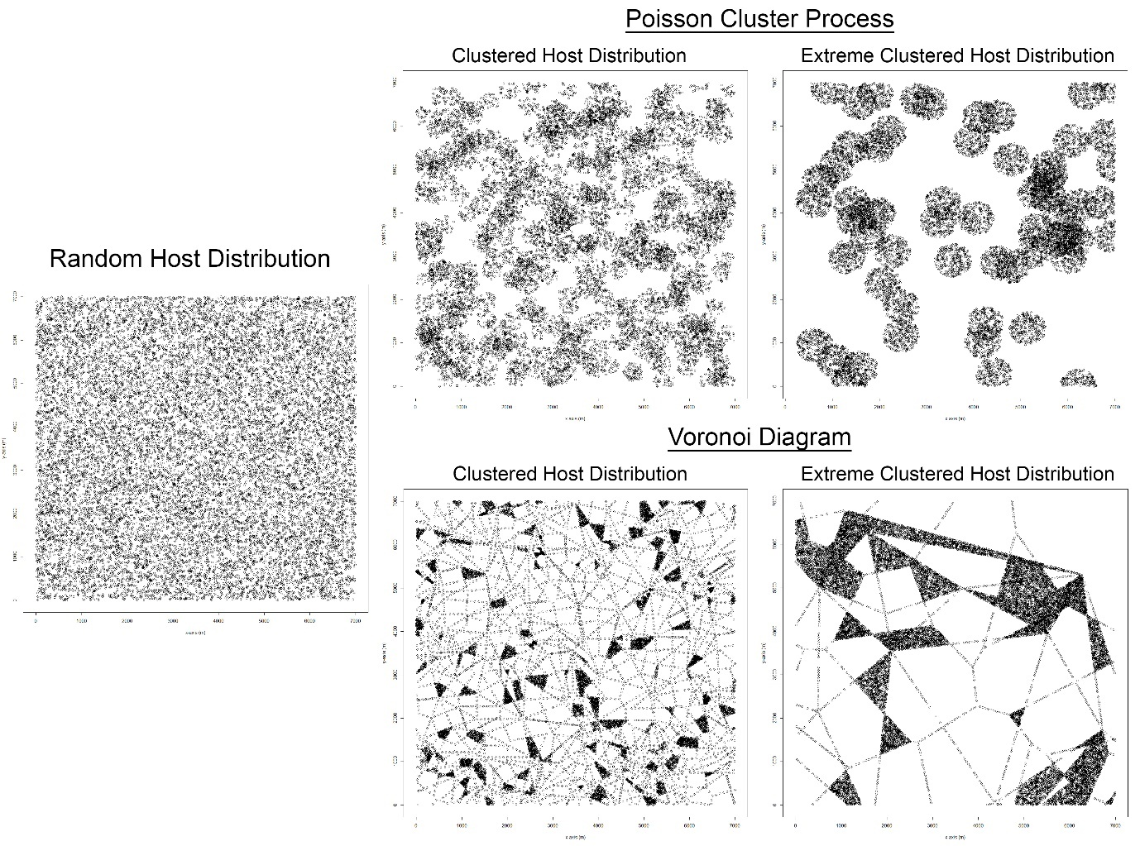

Figure S2: Examples of all the different host landscape types. Each plot has the same number of points (15,941).

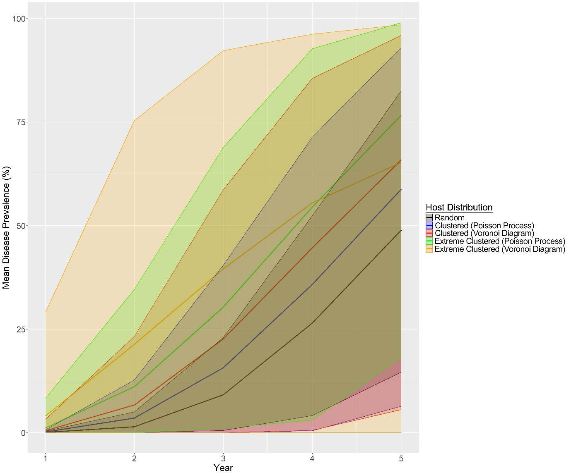

Figure S2: The change in mean disease prevalence of the host landscape types generated with the three different host distribution methods and with different levels of clustering. The envelopes represent the 95% quartile range which are estimated from 500 realizations for each year.

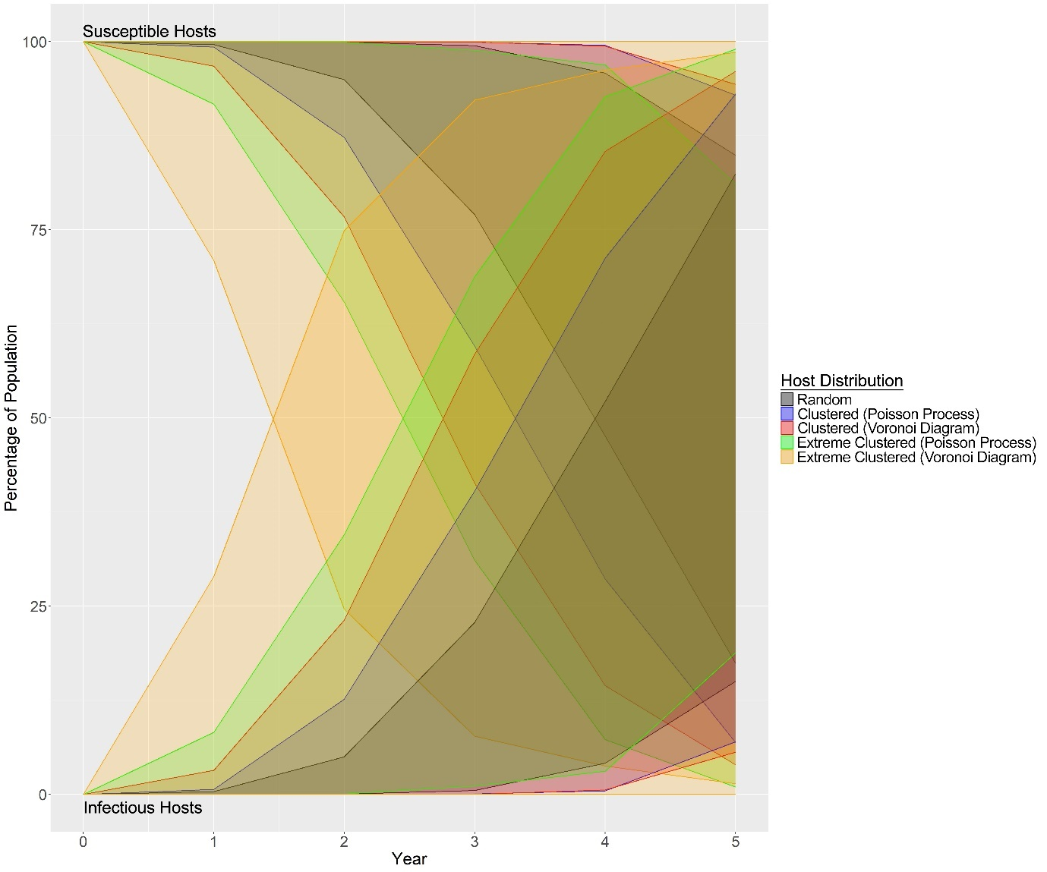

Figure S3: Graph showing the change in the percentage of susceptible and infectious hosts in the population for each of the host landscape types. Envelopes represent the 95% quartile range which are estimated from 500 realizations for each year.

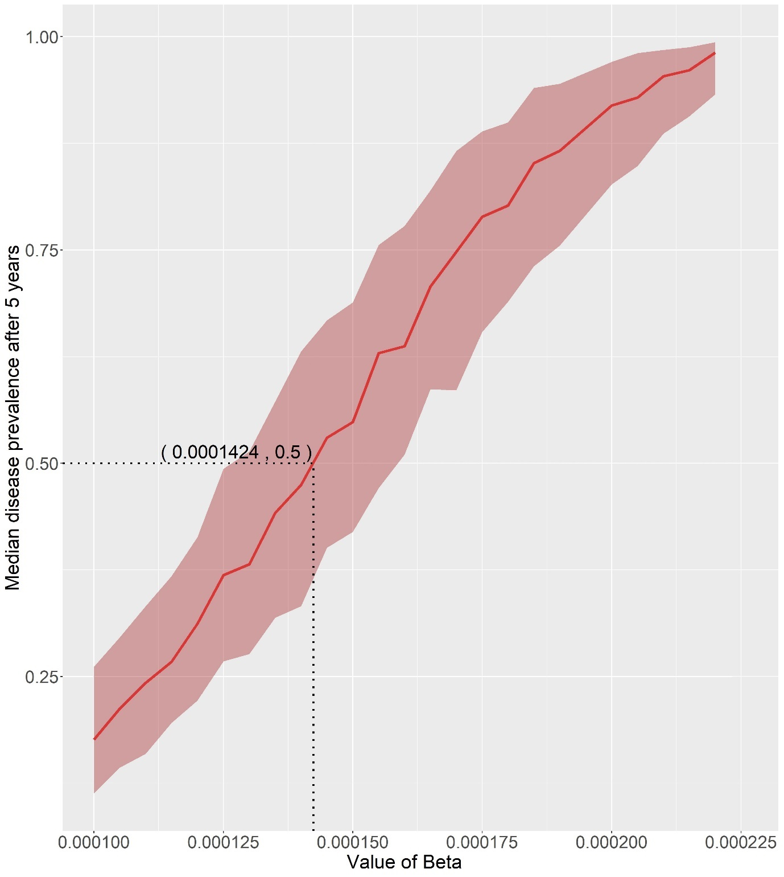

Figure S4: Graph showing the results of the line method used to parameterize the baseline infection rate ($β$) to achieve a median prevalence level of 50% after 5 years. Error envelope represents the interquartile range.

Table S1: Summary of how each strategy calculates the length of the radius. Where $n$ is the number of years, $g$ is the number of generations, $D$ is the estimated maximum yearly spread distance of the pest, and $δ$ is the estimated maximum spread distance of each generation.

|  |  |
| --- | --- |
| **Strategy** | **How Radius Length is Calculated** |
| In-to-Out (Gamma Year) | $${Radius}_{i}=gamma\left(n_{i}, -\frac{ln⁡(1-0.95)}{D}\right)$$ |
| In-to-Out (Gamma Gen) | $${Radius}_{i}=gamma\left(g_{i}, -\frac{ln⁡(1-0.95)}{δ}\right)$$ |
| In-to-Out (Linear) | $${Radius}_{i}=n_{i}×D$$ |
| Adaptive (Gamma Year) | $${Radius}_{i}=gamma\left(n_{i}, -\frac{ln⁡(1-0.95)}{D}\right)$$ |
| Adaptive (Gamma Gen) | $${Radius}_{i}=gamma\left(g_{i}, -\frac{ln⁡(1-0.95)}{δ}\right)$$ |
| Adaptive (Linear) | $${Radius}_{i}=n_{i}×D$$ |
| Multi-foci | $$Radius=D$$ |

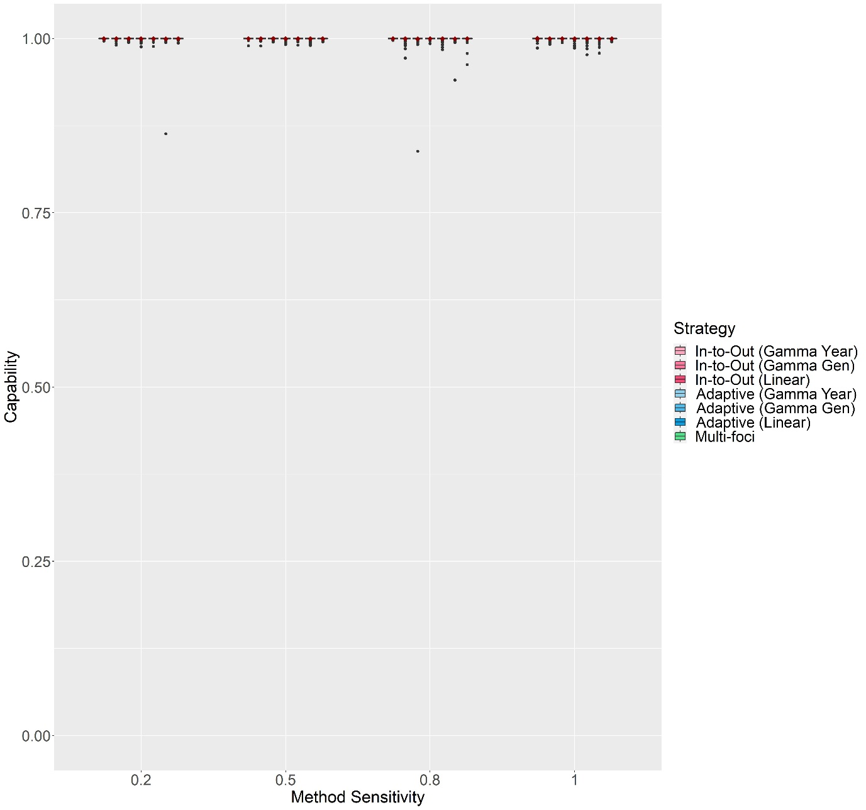

Figure S5: The change in Capability scores with Method Sensitivity of each delimiting strategy on a random host landscape in Scenario 1. The inspector-estimated spread distances matched the true values (550 m/generation and 750 m/year). For each realization, all delimiting strategies started from the origin of the epidemic, no asymptomatic period was included, and the inspector-estimated duration of the pest spread was matched with the true value (3 years). Boxplots were obtained from 500 iterations. Mean values are indicated with a dark red diamond.

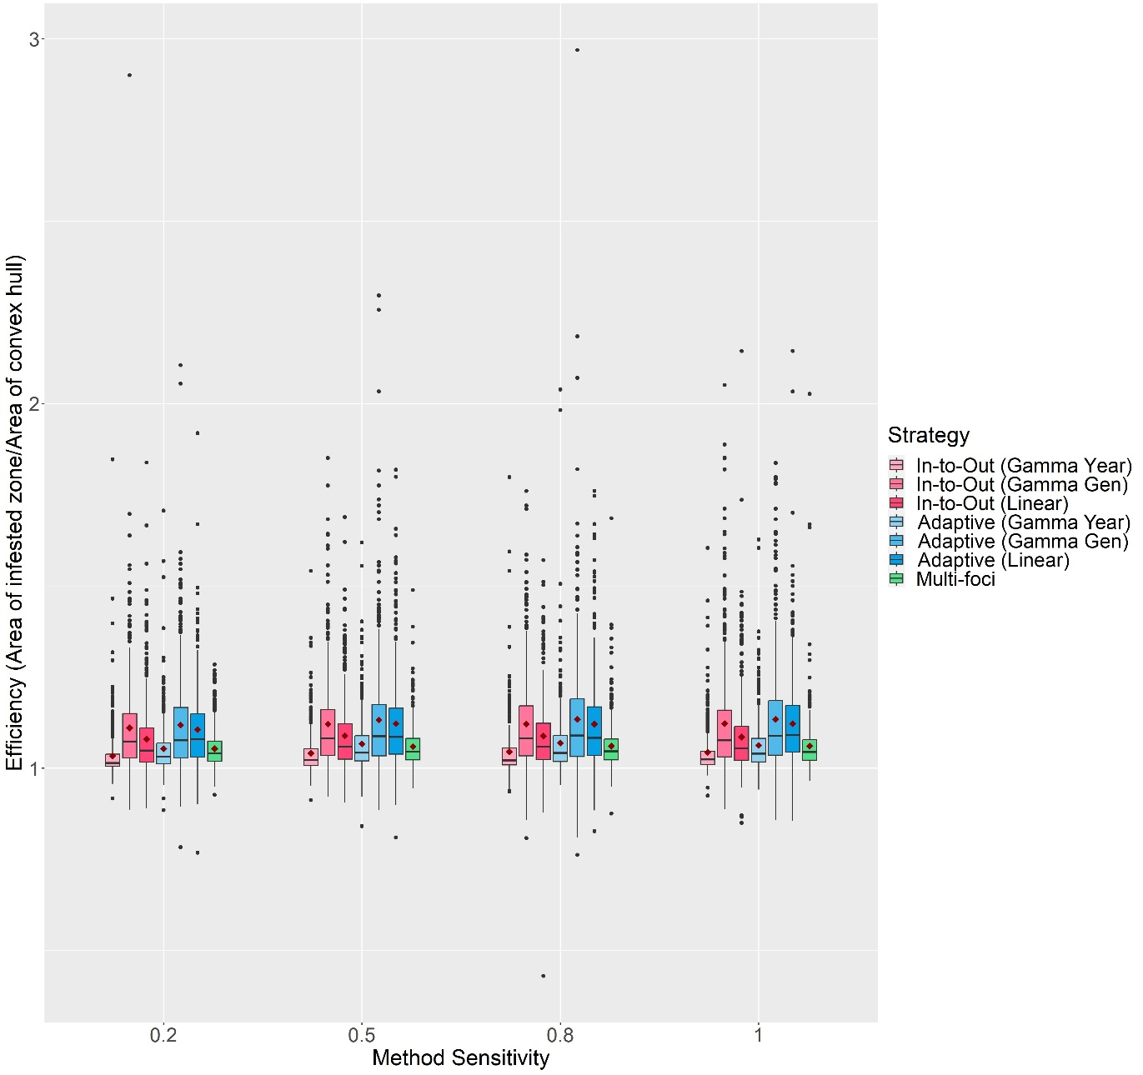

Figure S6: The change in Efficiency scores with Method Sensitivity of each delimiting strategy on a random host landscape in Scenario 1. The inspector-estimated spread distances matched the true values (550 m/generation and 750 m/year). For each realization, all delimiting strategies started from the origin of the epidemic, no asymptomatic period was included, and the inspector-estimated duration of the pest spread was matched with the true value (3 years). Boxplots were obtained from 500 iterations. Mean values are indicated with a dark red diamond.

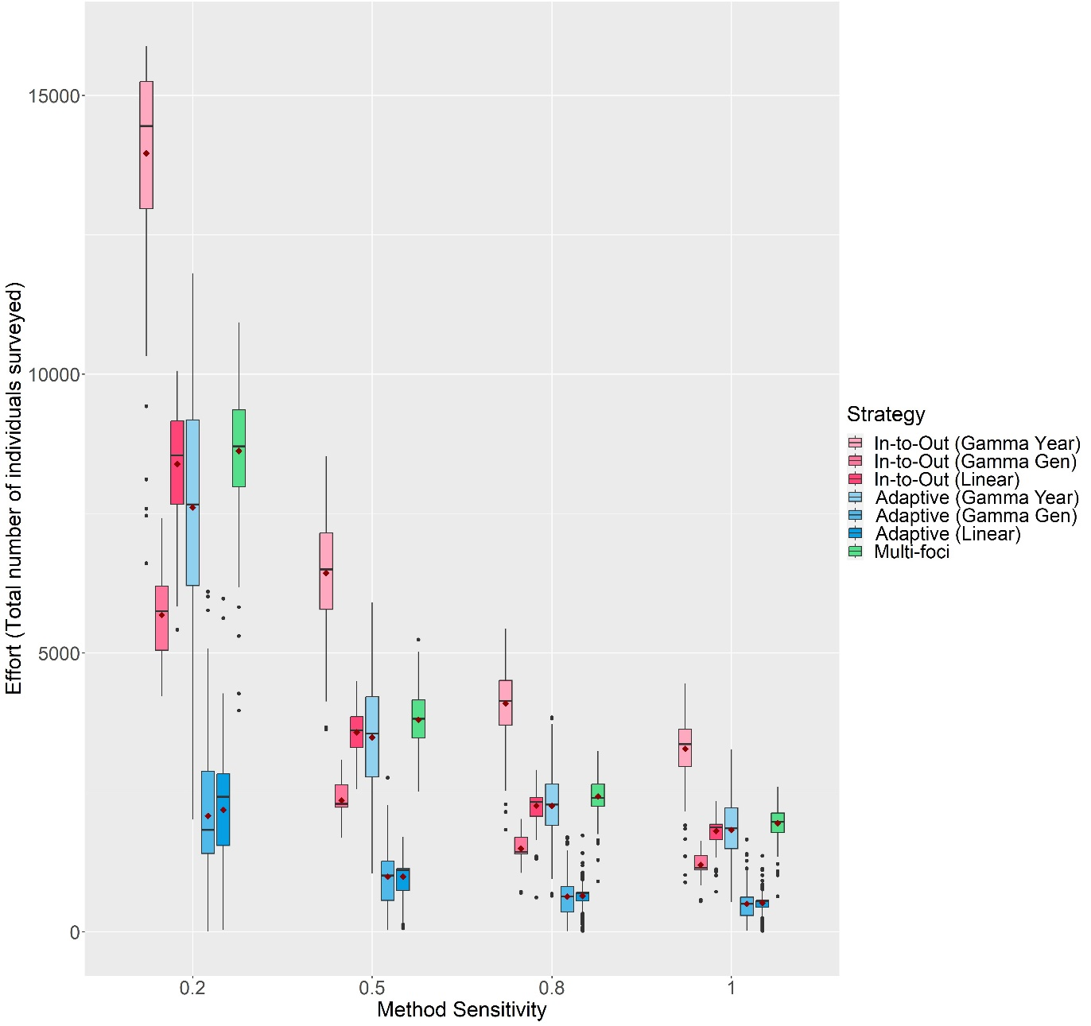

Figure S7: The change in Effort scores with Method Sensitivity of each delimiting strategy on a random host landscape in Scenario 1. The inspector-estimated spread distances matched the true values (550 m/generation and 750 m/year). For each realization, all delimiting strategies started from the origin of the epidemic, no asymptomatic period was included, and the inspector-estimated duration of the pest spread was matched with the true value (3 years). Boxplots were obtained from 500 iterations. Mean values are indicated with a dark red diamond.

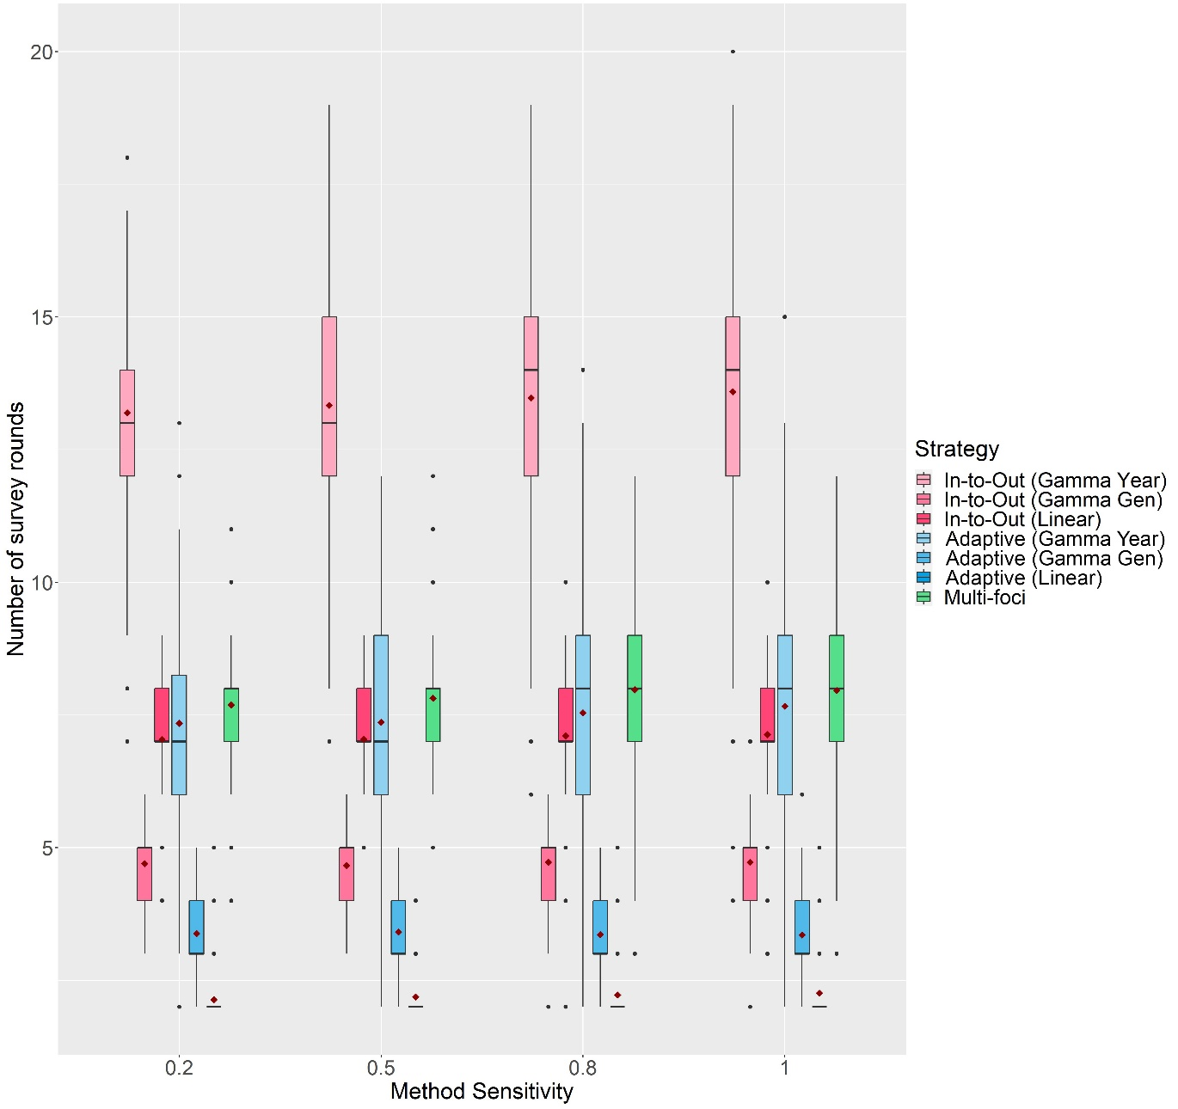

Figure S8: The change in the number of survey rounds each delimiting strategy took to delimit the potential infested zone on a random host landscape in Scenario 1 with Method Sensitivity. The inspector-estimated spread distances matched the true values (550 m/generation and 750 m/year). For each realization, all delimiting strategies started from the origin of the epidemic, no asymptomatic period was included, and the inspector-estimated duration of the pest spread was matched with the true value (3 years). Boxplots were obtained from 500 iterations. Mean values are indicated with a dark red diamond.

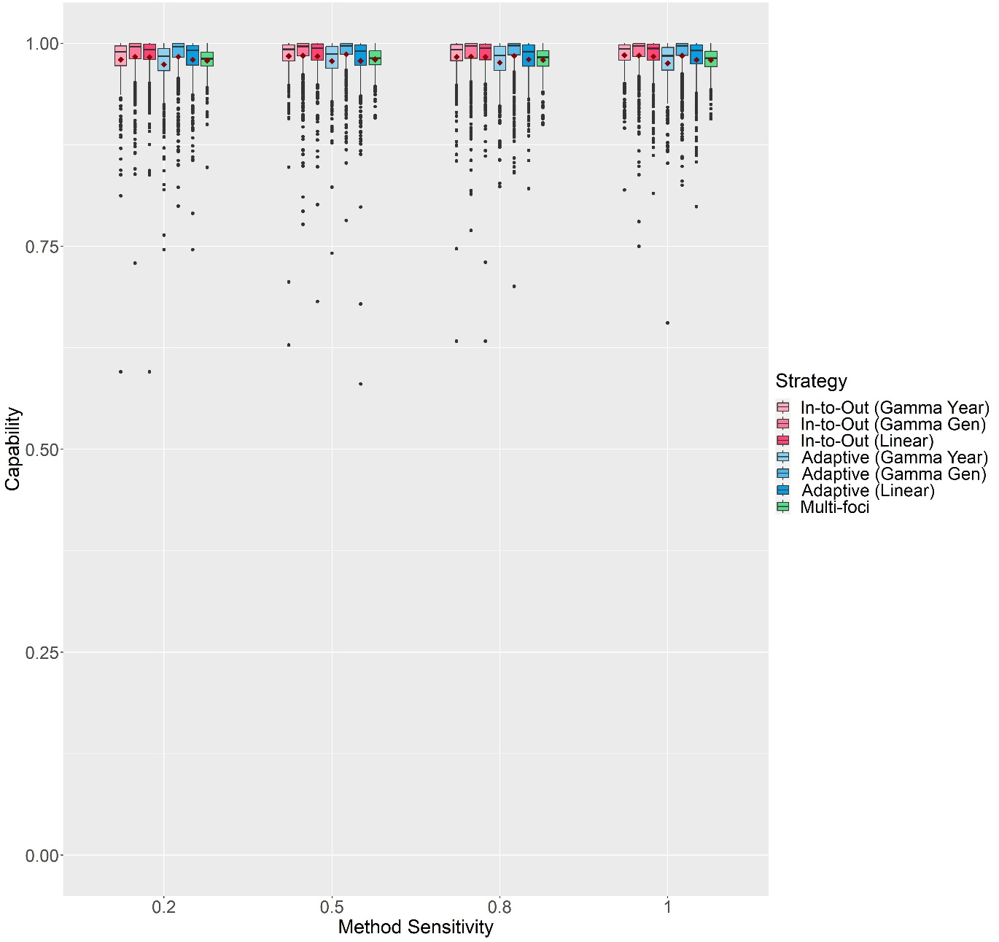

Figure S9: The change in Capability scores with Method Sensitivity of each delimiting strategy on a random host landscape in Scenario 2. The inspector-estimated spread distances matched the true values (550 m/generation and 750 m/year). For each realization, all delimiting strategies started from the origin of the epidemic, a 1-year asymptomatic period was included, and the inspector-estimated duration of the pest spread was matched with the true value (3 years). Boxplots were obtained from 500 iterations. Mean values are indicated with a dark red diamond.

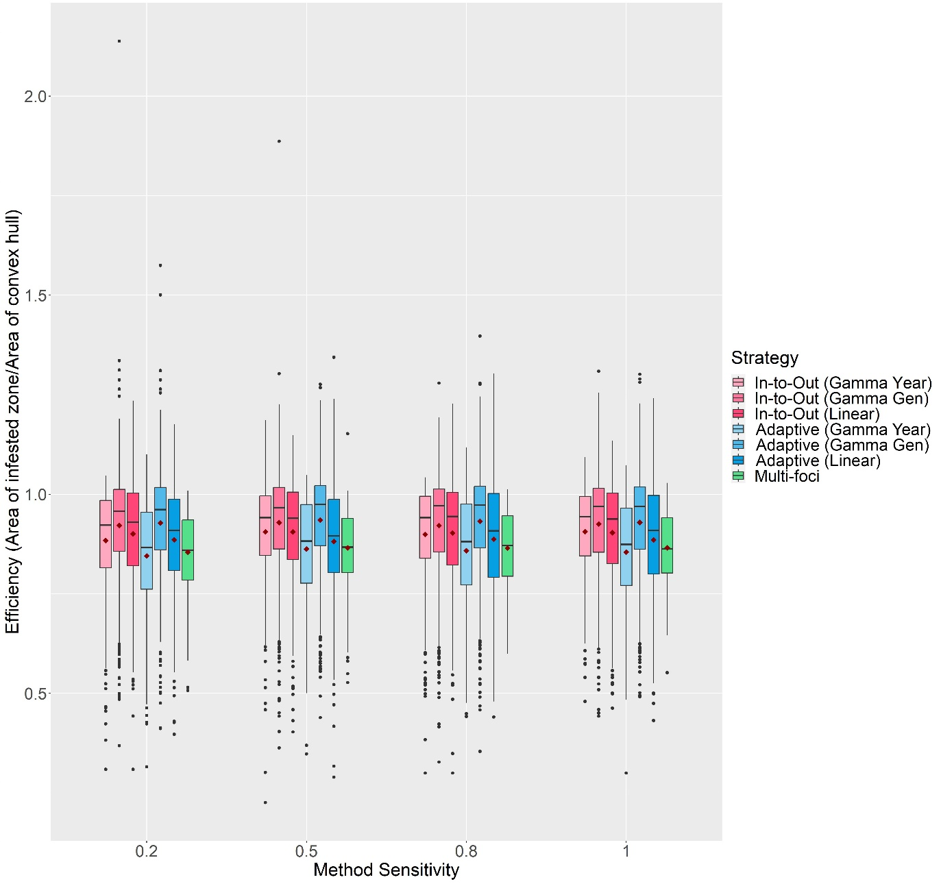

Figure S10: The change in Efficiency scores with Method Sensitivity of each delimiting strategy on a random host landscape in Scenario 2. The inspector-estimated spread distances matched the true values (550 m/generation and 750 m/year). For each realization, all delimiting strategies started from the origin of the epidemic, a 1-year asymptomatic period was included, and the inspector-estimated duration of the pest spread was matched with the true value (3 years). Boxplots were obtained from 500 iterations. Mean values are indicated with a dark red diamond.

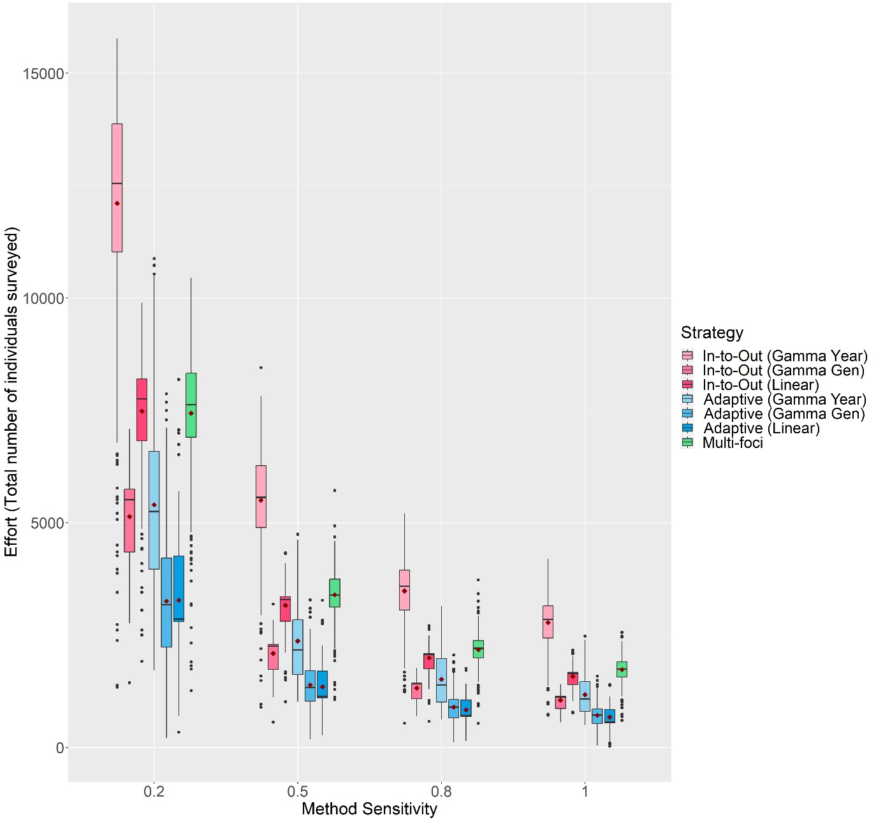

Figure S11: The change in Effort scores with Method Sensitivity of each delimiting strategy on a random host landscape in Scenario 2. The inspector-estimated spread distances matched the true values (550 m/generation and 750 m/year). For each realization, all delimiting strategies started from the origin of the epidemic, a 1-year asymptomatic period was included, and the inspector-estimated duration of the pest spread was matched with the true value (3 years). Boxplots were obtained from 500 iterations. Mean values are indicated with a dark red diamond.

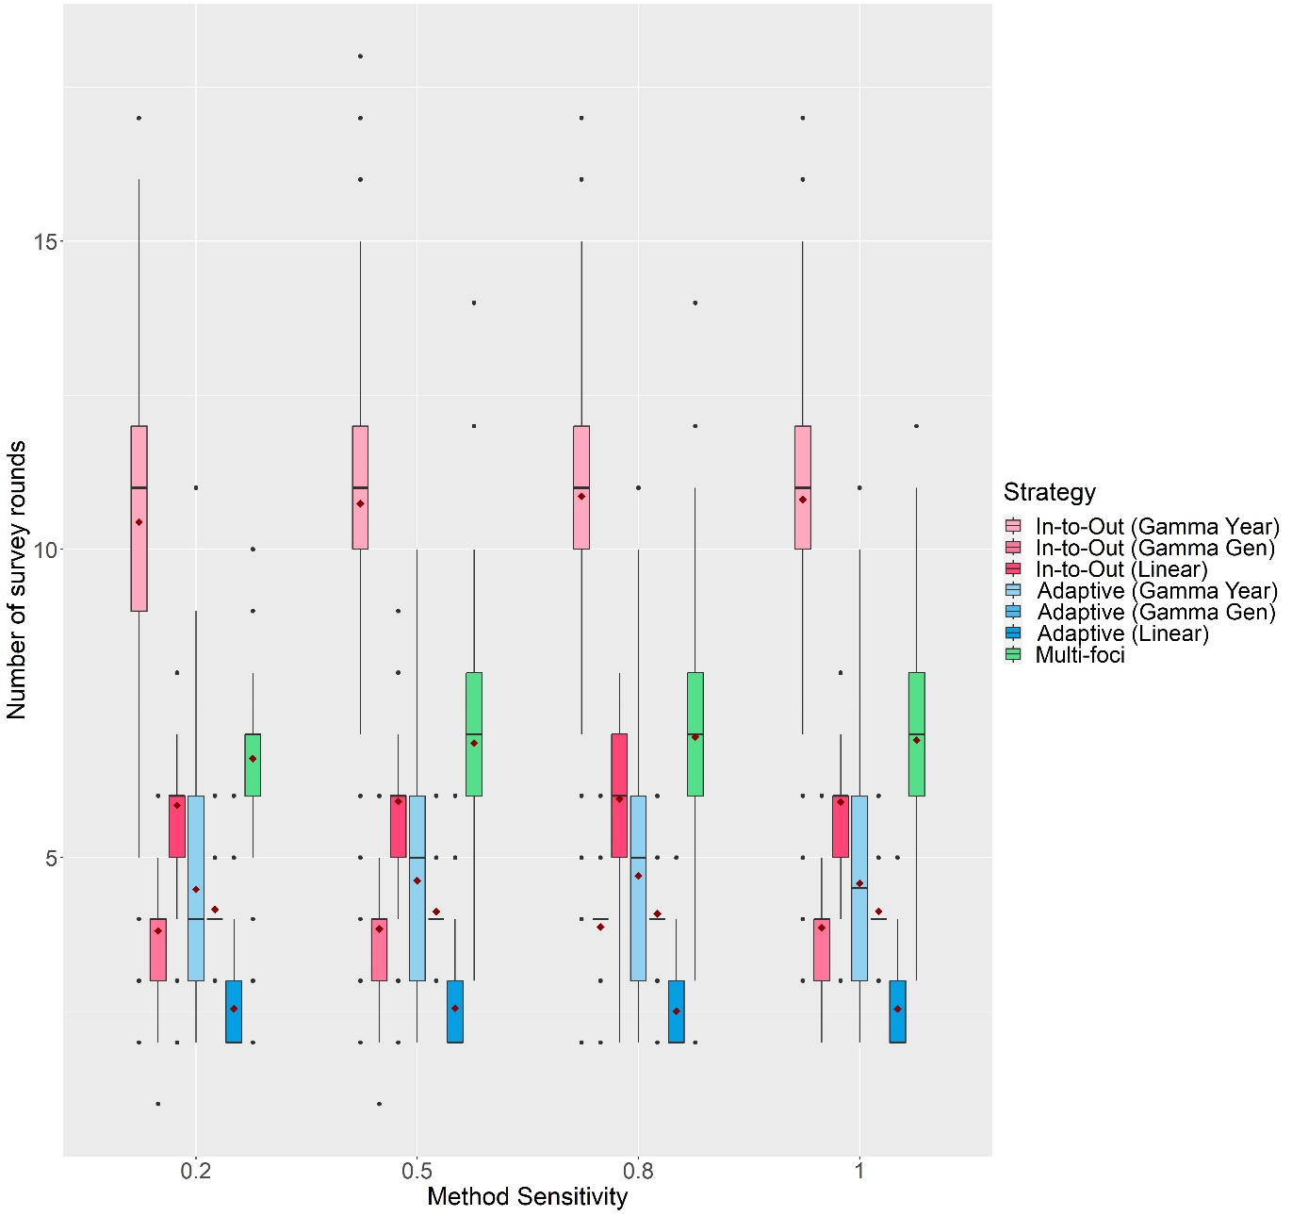

Figure S12: The change in the number of survey rounds each delimiting strategy took to delimit the potential infested zone on a random host landscape in Scenario 2 with Method Sensitivity. The inspector-estimated spread distances matched the true values (550 m/generation and 750 m/year). For each realization, all delimiting strategies started from the origin of the epidemic, a 1-year asymptomatic period was included, and the inspector-estimated duration of the pest spread was matched with the true value (3 years). Boxplots were obtained from 500 iterations. Mean values are indicated with a dark red diamond.

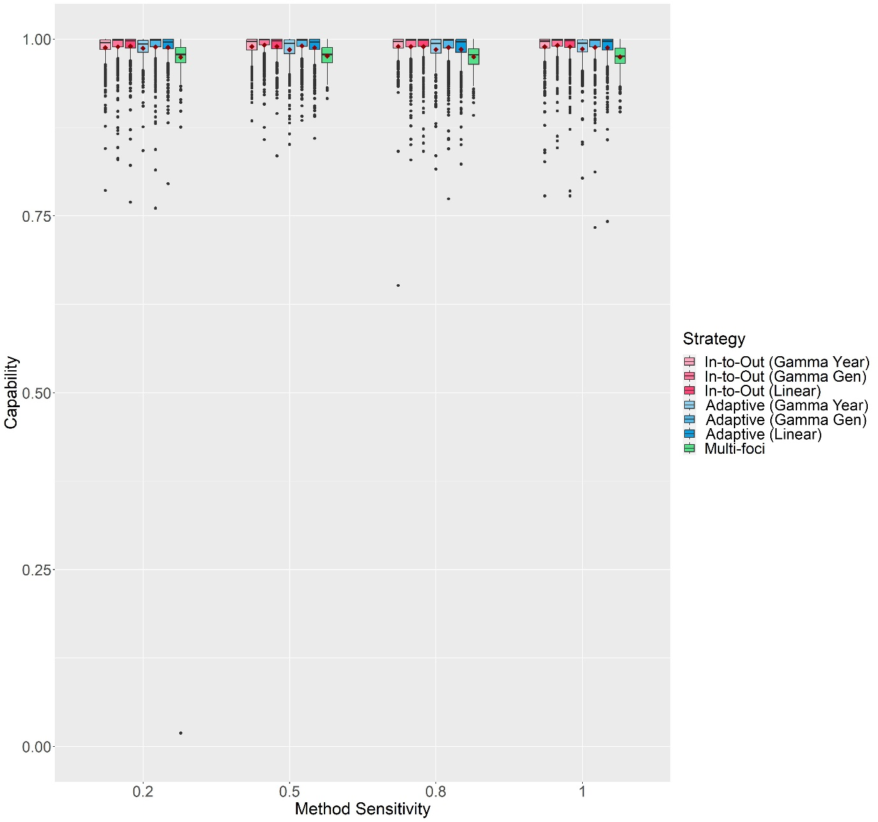

Figure S13: The change in Capability scores with Method Sensitivity of each delimiting strategy on a random host landscape in Scenario 3. The inspector-estimated spread distances matched the true values (550 m/generation and 750 m/year). For each realization, all delimiting strategies started from the same randomly selected symptomatic individual, a 1-year asymptomatic period was included, and the inspector-estimated duration of the pest spread was matched with the true value (3 years). Boxplots were obtained from 500 iterations. Mean values are indicated with a dark red diamond.

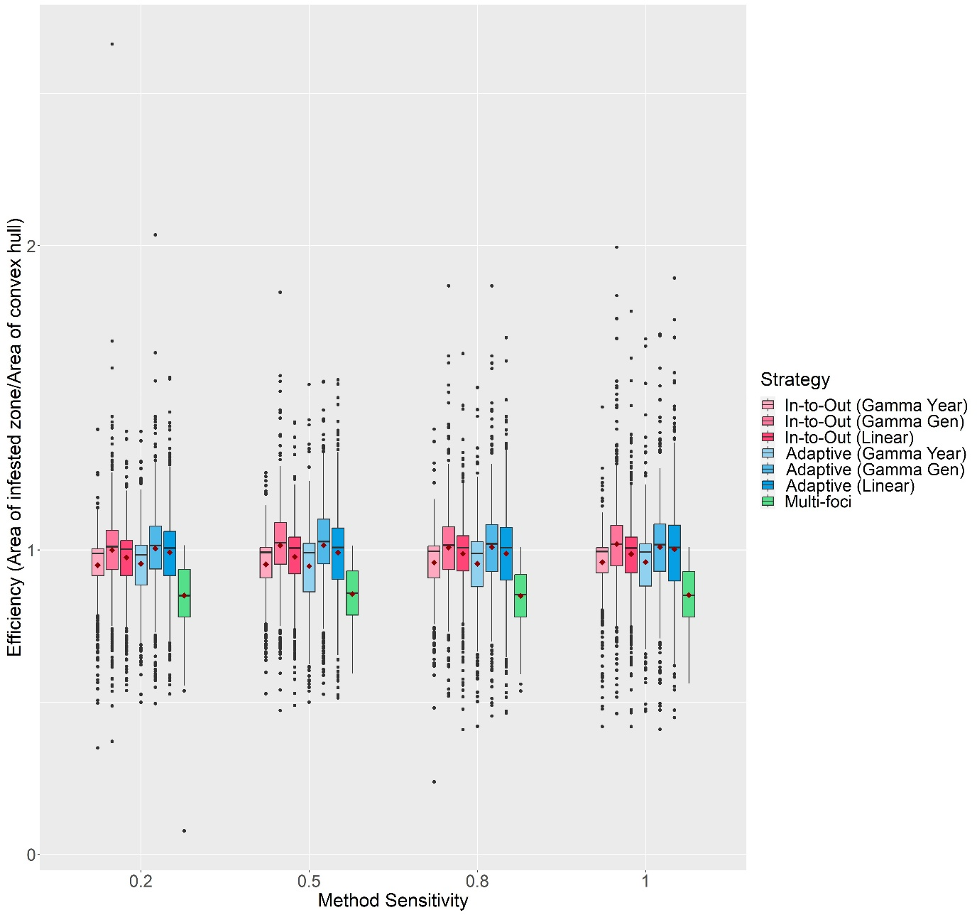

Figure S14: The change in Efficiency scores with Method Sensitivity of each delimiting strategy on a random host landscape in Scenario 3. The inspector-estimated spread distances matched the true values (550 m/generation and 750 m/year). For each realization, all delimiting strategies started from the same randomly selected symptomatic individual, a 1-year asymptomatic period was included, and the inspector-estimated duration of the pest spread was matched with the true value (3 years). Boxplots were obtained from 500 iterations. Mean values are indicated with a dark red diamond.

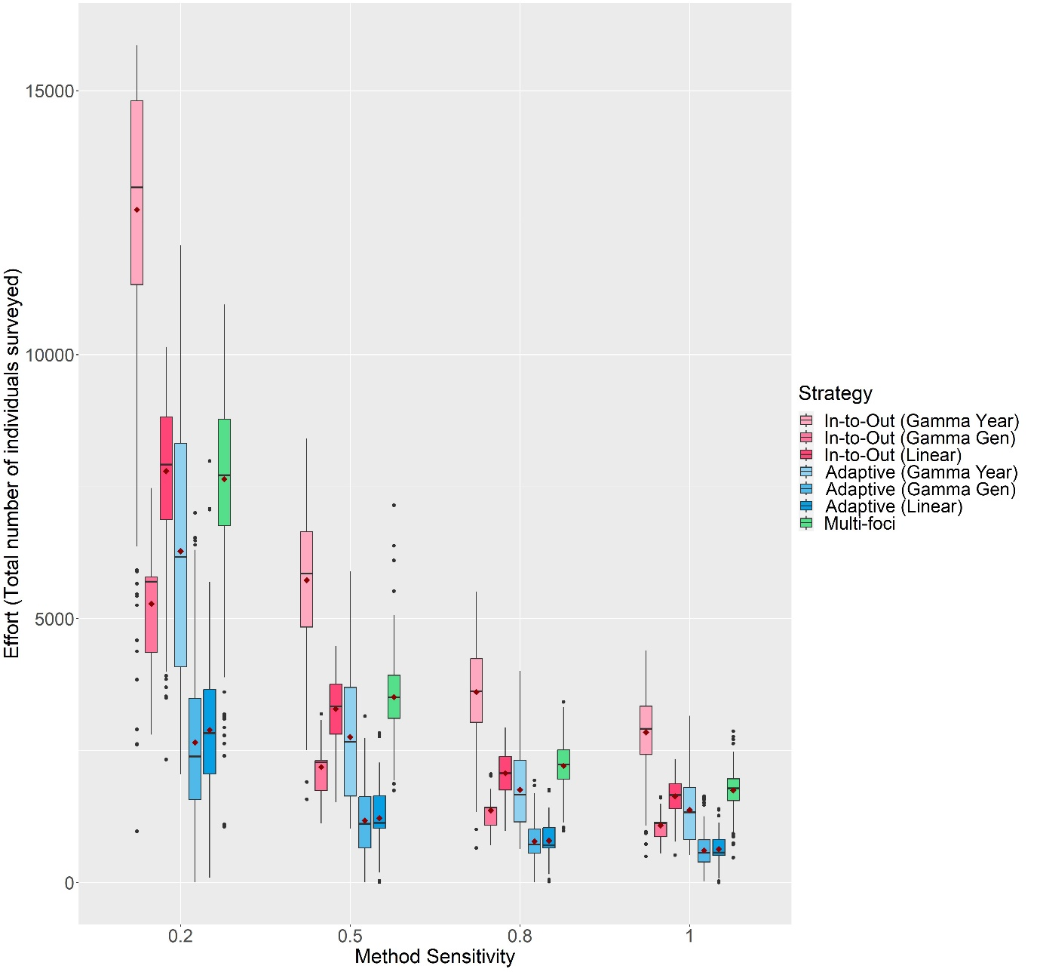

Figure S15: The change in Effort scores with Method Sensitivity of each delimiting strategy on a random host landscape in Scenario 3. The inspector-estimated spread distances matched the true values (550 m/generation and 750 m/year). For each realization, all delimiting strategies started from the same randomly selected symptomatic individual, a 1-year asymptomatic period was included, and the inspector-estimated duration of the pest spread was matched with the true value (3 years). Boxplots were obtained from 500 iterations. Mean values are indicated with a dark red diamond.

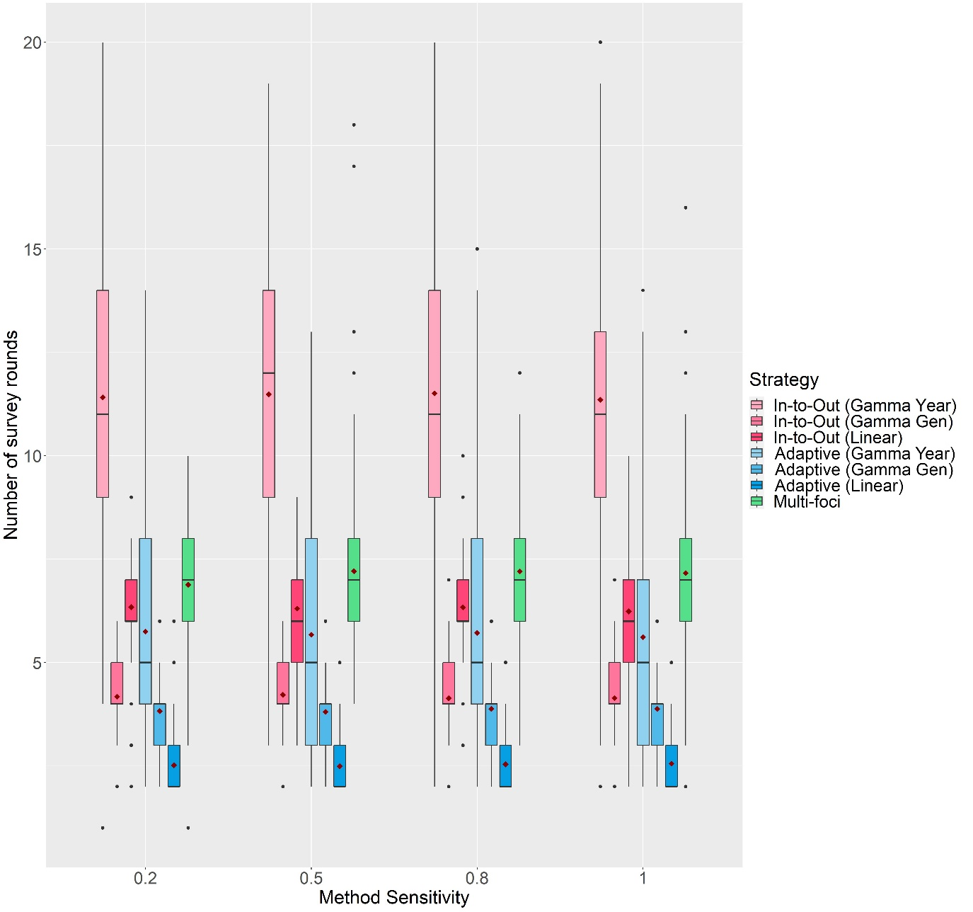

Figure S16: The change in the number of survey rounds each delimiting strategy took to delimit the potential infested zone on a random host landscape in Scenario 3 with Method Sensitivity. The inspector-estimated spread distances matched the true values (550 m/generation and 750 m/year). For each realization, all delimiting strategies started from the same randomly selected symptomatic individual, a 1-year asymptomatic period was included, and the inspector-estimated duration of the pest spread was matched with the true value (3 years). Boxplots were obtained from 500 iterations. Mean values are indicated with a dark red diamond.

**\*\*Figures S17 to S29 are large and difficult to view in this Word document. Hence, they have been uploaded as individual high-resolution images. Their captions are as follows:**

Figure S17: The change in Capability scores of all seven delimiting strategies on a random host landscape in Scenario 4 with Method Sensitivity, inspector-estimated spread distances and duration of pest spread. For each realization, all delimiting strategies started from the same randomly selected symptomatic individual, and a 1-year asymptomatic period was included. Boxplots were obtained from 500 iterations. Mean values are indicated with a dark red diamond.

Figure S18: The change in Efficiency scores of all seven delimiting strategies on a random host landscape in Scenario 4 with Method Sensitivity, inspector-estimated spread distances and duration of pest spread. For each realization, all delimiting strategies started from the same randomly selected symptomatic individual, and a 1-year asymptomatic period was included. Boxplots were obtained from 500 iterations. Mean values are indicated with a dark red diamond.

Figure S19: The change in Effort scores of all seven delimiting strategies on a random host landscape in Scenario 4 with Method Sensitivity, inspector-estimated spread distances and duration of pest spread. For each realization, all delimiting strategies started from the same randomly selected symptomatic individual, and a 1-year asymptomatic period was included. Boxplots were obtained from 500 iterations. Mean values are indicated with a dark red diamond.

Figure S20: The change in the number of survey rounds each delimiting strategy took to delimit the potential infested zone on a random host landscape in Scenario 4 with Method Sensitivity, inspector-estimated spread distances and duration of pest spread. For each realization, all delimiting strategies start from the same randomly selected symptomatic individual, and a 1-year asymptomatic period was included. Boxplots were obtained from 500 iterations. Mean values are indicated with a dark red diamond.

Figure S21: The change in Capability scores of the In-to-Out (Gamma Gen) and Adaptive (Gamma Gen) strategies on a random host landscape in Scenario 5 with the inspector-estimated spread distances, mean number of generations per year and duration of pest spread. For each realization, both delimiting strategies started from the same randomly selected symptomatic individual, and a 1-year asymptomatic period was included. Method sensitivity was kept constant at 0.5. Boxplots were obtained from 500 iterations. Mean values are indicated with a dark red diamond.

Figure S22: The change in Efficiency scores of the In-to-Out (Gamma Gen) and Adaptive (Gamma Gen) strategies on a random host landscape in Scenario 5 with the inspector-estimated spread distances, mean number of generations per year, and duration of pest spread. For each realization, both delimiting strategies started from the same randomly selected symptomatic individual, and a 1-year asymptomatic period was included. Method sensitivity was kept constant at 0.5. Boxplots were obtained from 500 iterations. Mean values are indicated with a dark red diamond.

Figure S23: The change in Effort scores of the In-to-Out (Gamma Gen) and Adaptive (Gamma Gen) strategies on a random host landscape in Scenario 5 with the inspector-estimated spread distances, mean number of generations per year, and duration of pest spread. For each realization, both delimiting strategies started from the same randomly selected symptomatic individual, and a 1-year asymptomatic period was included. Method sensitivity was kept constant at 0.5. Boxplots were obtained from 500 iterations. Mean values are indicated with a dark red diamond.

Figure S24: The change in the number of survey rounds the In-to-Out (Gamma Gen) and Adaptive (Gamma Gen) strategies took to delimit the potential infested zone on a random host landscape in Scenario 5 with the inspector-estimated spread distances, mean number of generations per year, and duration of pest spread. For each realization, both delimiting strategies started from the same randomly selected symptomatic individual, and a 1-year asymptomatic period was included. Method sensitivity was kept constant at 0.5. Boxplots were obtained from 500 iterations. Mean values are indicated with a dark red diamond.

Figure S25: Change in the Capability scores of the delimiting strategies on various host landscape types with the inspector-estimated spread distances and duration of pest spread. For each realization, all delimiting strategies started from the same randomly selected symptomatic individual, and a 1-year asymptomatic period was included. Method sensitivity was kept constant at 0.5. Boxplots were obtained from 500 iterations except for the Extreme Clustered Host Distribution columns where boxplots were obtained from 150 iterations. Mean values are indicated with a dark red diamond.

Figure S26: The change in Efficiency scores of the delimiting strategies on various host landscape types with inspector-estimated spread distances and duration of pest spread. For each realization, all delimiting strategies started from the same randomly selected symptomatic individual, and a 1-year asymptomatic period was included. Method sensitivity was kept constant at 0.5. Boxplots were obtained from 500 iterations except for the Extreme Clustered Host Distribution columns where boxplots were obtained from 150 iterations. Mean values are indicated with a dark red diamond.

Figure S27: The change in Effort scores of the delimiting strategies on various host landscape types with the inspector-estimated spread distances and duration of pest spread. For each realization, all delimiting strategies started from the same randomly selected symptomatic individual, and a 1-year asymptomatic period was included. Method sensitivity was kept constant at 0.5. Boxplots were obtained from 500 iterations except for the Extreme Clustered Host Distribution columns where boxplots were obtained from 150 iterations. Mean values are indicated with a dark red diamond.

Figure S28: The change in the number of survey rounds each of the delimiting strategies took to delimit the potential infested zone on various host landscape types with the inspector-estimated spread distances and duration of pest spread. For each realization, all delimiting strategies started from the same randomly selected symptomatic individual, and a 1-year asymptomatic period was included. Method sensitivity was kept constant at 0.5. Boxplots were obtained from 500 iterations except for the Extreme Clustered Host Distribution columns where boxplots were obtained from 150 iterations.

Figure S29: Change in the proportion of times perfect Capability was achieved by each of the delimiting strategies on various host landscape types with the inspector-estimated spread distances and duration of pest spread. For each realization, all delimiting strategies started from the same randomly selected symptomatic individual, and a 1-year asymptomatic period was included. Method Sensitivity was kept constant at 0.5. Each bar was obtained from 500 iterations.

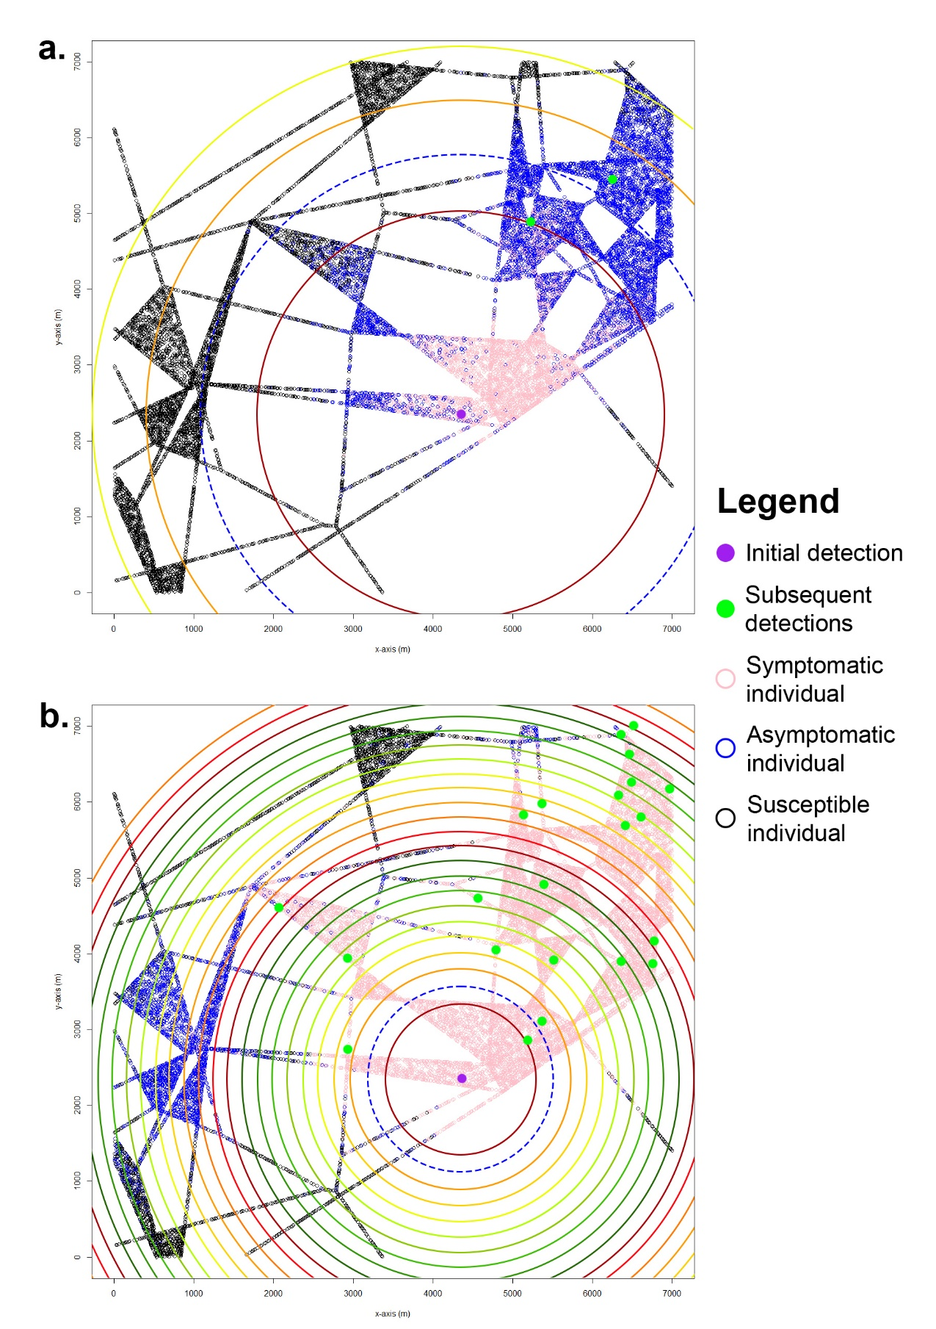

Figure S30: Realizations of the Adaptive Gamma Gen (a) and Adaptive Gamma Year (b) strategies on the same Extreme Voronoi landscape and same simulated epidemic. Pink, blue and black circles indicate the symptomatic status of individuals after delimiting the potential infested zone. Both strategies started day 731 after the initial infection. The Gamma Gen strategy ended on day 791 while the Gamma Year strategy ended on day 1421. Method Sensitivity was 0.5, the inspector-estimated (IE) spread distances were greatly underestimated (450 m/year and 350 m/generation) and the IE duration of the pest spread was overestimated. Large, coloured circles represent the boundaries of each survey round.

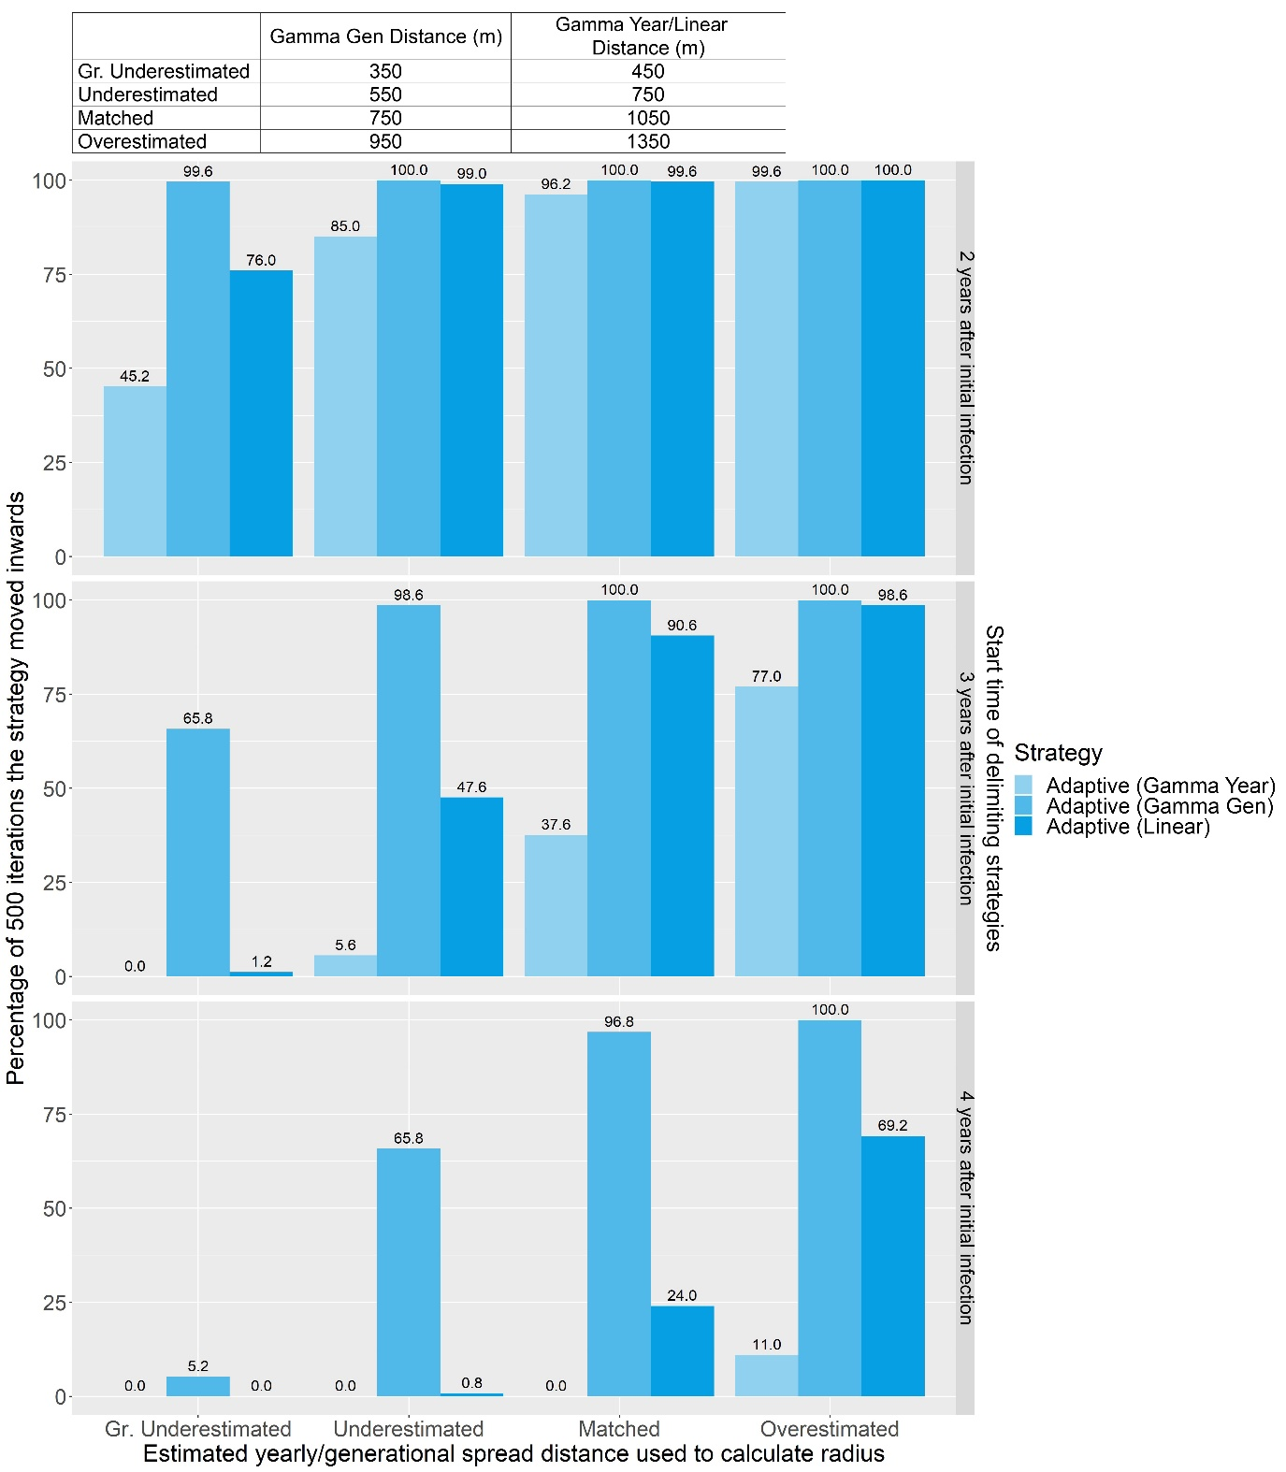

Figure S31: Bar graph showing how frequently each version of the Adaptive strategy correctly estimated the distance of epidemic spread and moved inwards on a random host landscape and when Method Sensitivity = 0.5.

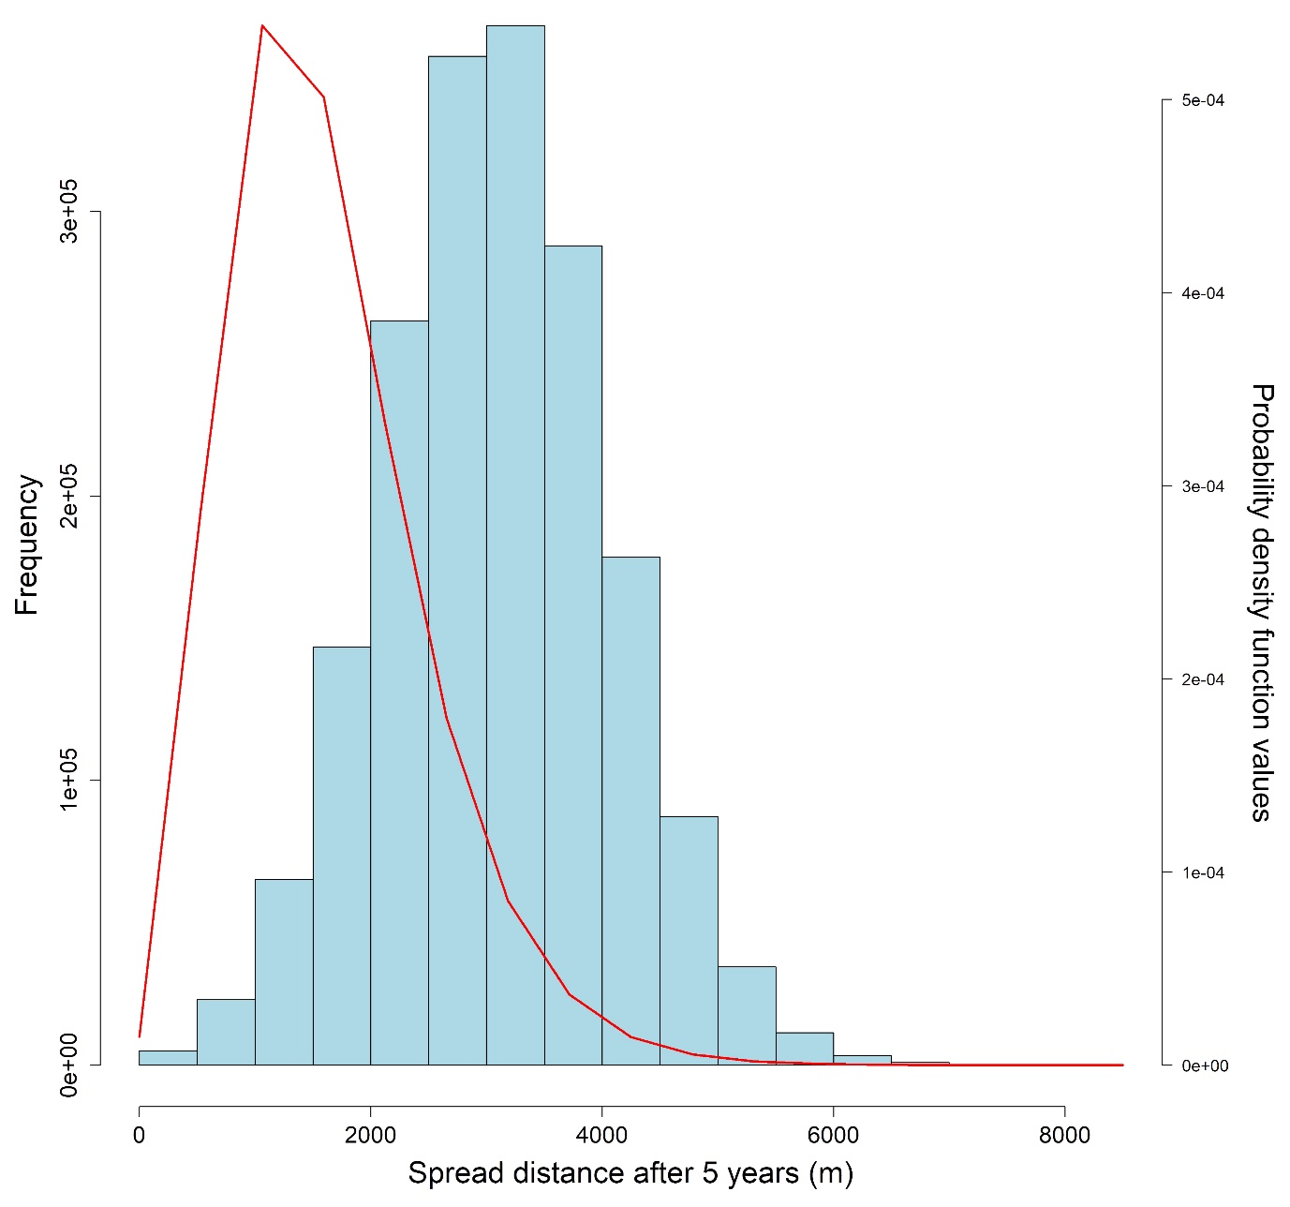

Figure S32: Histogram of the spread distances after five years and the probability density function values of a gamma distribution with a shape parameter value of 5 and a rate parameter value calculated with $-\frac{\ln{(1-0.95)}}{1056.911}$.

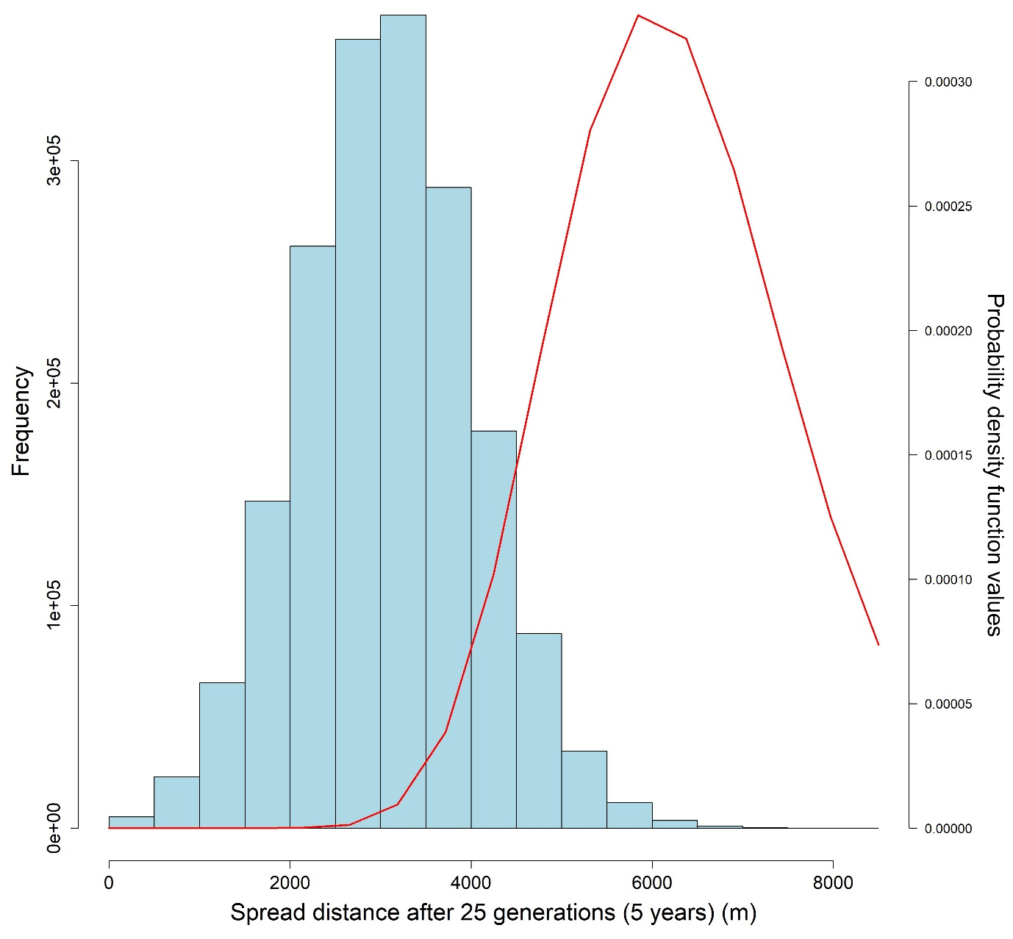

Figure S33: Histogram of the spread distances after twenty-five generations (five years) and the probability density function values of a gamma distribution with a shape parameter value of 25 and a rate parameter value calculated with $-\frac{\ln{(1-0.95)}}{737.69}$.

## Animated Figures



Figure SA1: Animated GIF showing the spread of the simulated pest in a random host landscape. Black circles indicate susceptible individuals, pink dots represent symptomatic individuals, blue dots represent asymptomatic individuals, and the red dot represents the first infected individual or the origin of the epidemic.



Figure SA2: Animated GIF showing how the In-to-Out strategy works. Colored dots represent detections of infected individuals, while the corresponding-colored bands represent the surveys conducted following these detections. The final purple circle represents the boundary of the delimited potential infested zone.



Figure SA3: Animated GIF showing how the Adaptive strategy works when a detection is made in the preliminary survey. Colored dots represent detections of infected individuals, while the corresponding-colored bands represent the surveys conducted following these detections. The final purple circle represents the boundary of the delimited potential infested zone.



Figure SA4: Animated GIF showing how the Adaptive strategy works when no detection is made in the preliminary survey. Colored dots represent detections of infected individuals, while the corresponding-colored bands represent the surveys conducted following these detections. The final purple circle represents the boundary of the delimited potential infested zone.



Figure SA5: Animated GIF showing how the Multi-foci strategy works. Colored dots represent detections of infected individuals, while the corresponding-colored bands represent the surveys conducted following these detections. The final purple circle represents the boundary of the delimited potential infested zone.



Figure SA6: Animated GIF showing a realization of the Adaptive (Gamma Gen) strategy on an Extreme Clustered Poisson Cluster Process host landscape. The purple dot represents the initial detection, pink circles represent symptomatic individuals, blue circles represent asymptomatic individuals, black circles represent susceptible individuals, and the green dot represents the subsequent detection. Large colored circles represent the boundaries of the survey bands. The blue dotted circle represents the outer boundary of the preliminary survey.



Figure SA7: Animated GIF showing a realization of the Adaptive (Gamma Year) strategy on the same Extreme Clustered Poisson Cluster Process host landscape as Fig. SA6. The purple dot represents the initial detection, pink circles represent symptomatic individuals, blue circles represent asymptomatic individuals, black circles represent susceptible individuals, and the green dot represents the subsequent detection. Large colored circles represent the boundaries of the survey bands. The blue dotted circle represents the outer boundary of the preliminary survey.



Figure SA8: Animated GIF showing a realization of the Individual Based Model and Multi-foci strategy on an Extreme Clustered Voronoi Diagram host landscape. The inspector-estimated (IE) annual spread distance of the Multi-foci strategy matched the true value of the simulated pest (1050 m/yr) and Method Sensitivity was 0.5. The purple dot represents the initial detection, pink dots represent symptomatic individuals, blue dots represent asymptomatic individuals, black circles represent susceptible individuals, the green dot represents the origin of the epidemic, red and orange dots represent the detections made during the survey rounds. Large multi-colored circles or globulus shapes represent the outer boundaries of survey rounds. The final shape with a green outline and purple filling represents the delimited potential infested zone.



Figure SA9: Animated GIF showing a realization of the Adaptive (Gamma Gen) strategy on the same Extreme Clustered Voronoi Diagram host landscape, starting symptomatic host, and realization of the Individual Based Model as in Fig. SA8. The inspector-estimated (IE) generational spread distance of the Adaptive (Gamma Gen) strategy matched the true value of the simulated pest (750 m/yr) and Method Sensitivity was 0.5. The purple dot represents the initial detection, pink dots represent symptomatic individuals, blue dots represent asymptomatic individuals, black circles represent susceptible individuals, the green dot represents the origin of the epidemic, red and orange dots represent the detections made during the survey rounds. Large multi-colored circles represent the boundaries of survey rounds, and the highlighted band shows the survey area for that round. The final shape with a green outline and purple filling represents the delimited potential infested zone.